Accenture Guidance

Access Packages: Governing Azure Resource Roles
Title: | Access Packages: Governing Azure Resource Roles
Version: | 1.0
Date: | 12/15/2024

Overview
Rolls-Royce is seeking guidance regarding governing the use and lifecycle of Azure Resource Roles. This will provide an automated request/approval workflow for users to request access to an access package containing the security group with Azure Resource Roles assigned. This will ensure JiT (Just in Time) access by limiting the group membership duration, while still requiring users to turn on PIM. It will ensure JEA (Just Enough Access) by separating duties in different role groups.
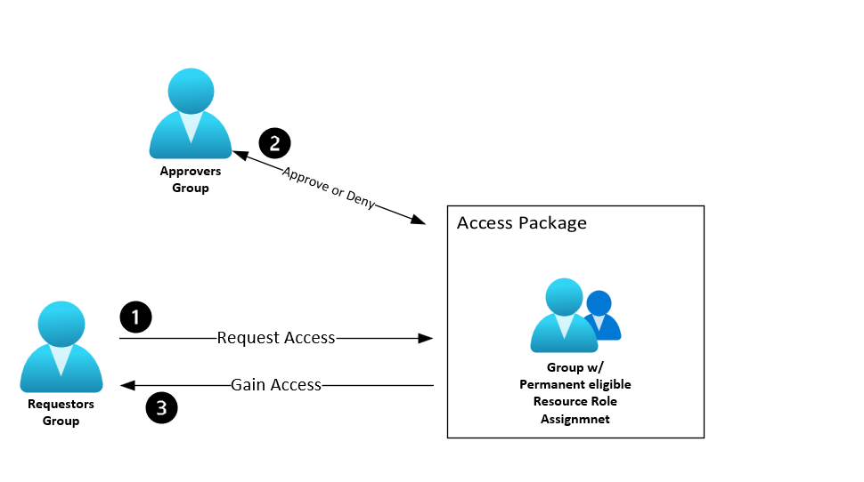

Solution Components

Cloud Only Groups
These groups are cloud only and will be used as the “role group”, they will be assigned the specified role as permanent eligible.
• The prefix for each group will be: CL-M-USGV-PIM-O-HT-AP_ with the rest of the name being the Azure resource role assigned to the group and the first 4 characters of the subscription id or the management group it’s scoped to
NOTE: some of these groups will have more than one role assigned to it, in that case it will be part of the 3 groups of “Low Risk” , “High Risk”, and “Most Privileged”

On-Prem Synced Groups
These groups will be on premise synced groups that will contain team members to be designated as approvers, requestors, or both. Noting that a requestor by design can not approve their own request. Named:
• SGG-US-ALL-PIM-O-HT-AP_USPOTS_REQUESTORS – Members of this group are the ONLY ones who can see/request these access packages. If anyone needs access to the access packages they must be added to this group.
• SGG-US-ALL-PIM-O-HT-AP_USPOTS_APPROVERS – Members of this group are the approvers who approve access to the access packages.

Access Packages
• Each access package name will have the prefix of rrrz-ap-ugv-d-alz-pim- and the remaining part of the name is the role in the access package or if there are multiple roles, the group name will be used, ex, “low risk”, “high risk”, etc..

1.3.1 Catalog
• rrrz-ctlg-ugv-d-alz-pim - A catalog will be created to contain all the access packages.

1.3.2 Access Package Policy Details
• The policy is what holds all the settings for governance, lifecycle management, access reviews and requestor settings:
Lifecycle Settings:
• Access to access package will last 365 days from the approval date
Requestor Settings:
• Only the requestor group in 1.2 can see/request the access package
Access Reviews Settings:
• Every 6 months, reviewers are the same group as the approvers

Scope
The current scope of the Terraform code is on the management group level. If this needs to be scoped on a subscription level, the following values in the following files need to be modified:
- File – roles_and_groups/main.tf
  - Comment out lines 2-4 and comment in lines 7-9
  - Comment out line 40 and comment in line 39
  - Comment out line 49 and comment in line 48
  - Make sure “subscription_id” is present as a variable in the variables.tf
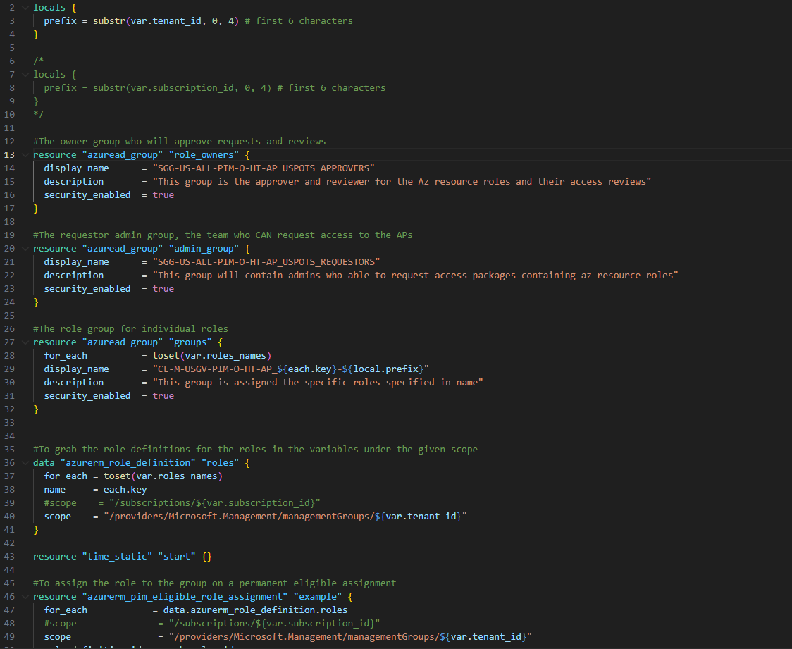
Figure 1 roles_and_groups/main.tf

- File – multirole_group_assignment/main.tf
  - Comment out lines 2-4 and comment in lines 7-9
  - Comment out line 23 and comment in line 22
  - Comment out line 32 and comment in line 31
  - Make sure “subscription_id” is present as a variable in the variables.tf

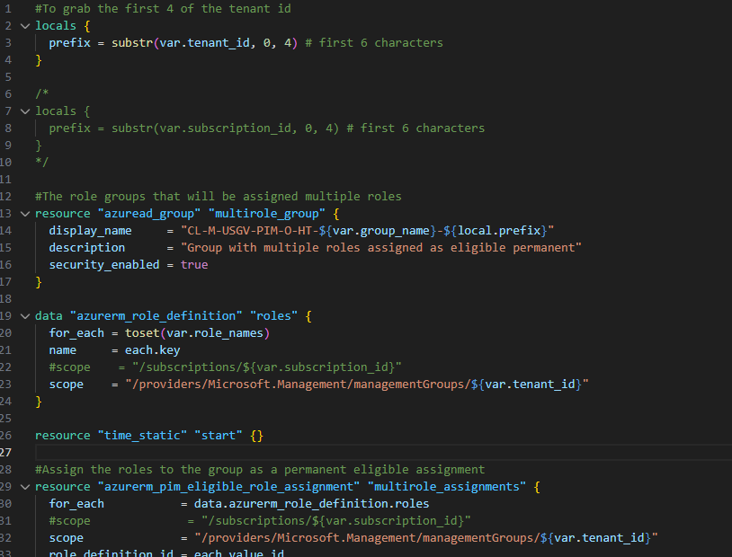
Figure 2 Multirole_group_assignment/main.tf

Assigned Resource Roles
In the current solution there are 3 role groups, each has a set of Azure resource roles, as follows:
- “Low Risk”
  - Reader
  - Microsoft Sentinel Contributor
  - Logic App Contributor
  - Cost Management Reader
  - Security Reader
  - Support Request Contributor
  - Monitoring Reader
  - Billing Reader
  - Monitoring Contributor
  - Workbook Contributor
  - Log Analytics Reader
  - Microsoft Sentinel Responder

- “High Risk”
  - Security Reader
  - Reader
  - Cost Management Contributor
  - Microsoft Sentinel Playbook Operator
  - Logic App Operator
  - Virtual Machine User Login
  - Microsoft Sentinel Contributor
  - Logic App Contributor
  - Cost Management Reader
  - Security Reader
  - Support Request Contributor
  - Monitoring Reader
  - Billing Reader
  - Monitoring Contributor
  - Workbook Contributor
  - Log Analytics Reader
  - Microsoft Sentinel Reader
- “Most Privileged”
  - Owner
  - Contributor
  - Security Admin
  - Reservation Purchaser

Permissions Needed

Pipeline Permissions
The pipeline will be running using a managed identity, to be able to successfully run the pipeline, the managed identity needs the following:
- Entra ID Roles:
  - Groups Administrator
  - Privileged Access Administrator
  - Identity Governance Administrator
- Azure Resource Role (on the scope needed):
  - User Access Administrator
- Graph API permissions:
  - EntitlementManagement.ReadWrite.All

Powershell Scripts Permissions
These are the permissions needed to run the Powershell scripts in the cloud shell
- Entra ID Roles:
  - Application Administrator
  - Privileged Role Administrator
  - Reports Reader
- Azure Resource Role:
  - Managed Identity Contributor
  - Storage Account Contributor

2. Runtime / Deployment

2.1 Change Role Settings
Before the Terraform is able to assign these roles to the groups, the “Allow permanent eligible assignment” option must be turned on for each role. Instructions from MS on how to change the role settings can be found here: https://learn.microsoft.com/en-us/entra/id-governance/privileged-identity-management/pim-resource-roles-configure-role-settings

2.2 Variables

2.2.1 Scoped to Subscription
As shown in section 1.4, the script can be scoped to subscription or management group. The variables for each must be present in all the variable files. It is initially defined in the main variables.tf
- Subscription_id = Subscription ID to which the access will be scoped
- The commented in/out lines in the files in section 1.4

2.2.2 Scoped to Management Group
If this solution needs to be scoped to a Management Group, then the “tenant_id” variable must be modified in the main variables.tf to the ID of the management group to be scoped to.
- Tenant_id = Management group ID to which the access will be scoped
- The commented in/out lines in the files in section 1.4

2.2.3 Adding single or multiple roles
If new single or multiple roles need to be added to create new access packages, ONLY the main variables.tf file needs to be modified.
- Single Role Groups :
  - Add the needed roles after line 5. Comma separated and in quotes
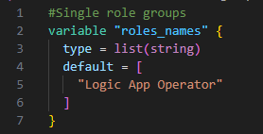
Figure 2 single roles in variables.tf
Multi Role Groups :
  - Add the desired new group name and the desired roles, in quotes and comma separated, following the previous 3 examples. Begin on line 75
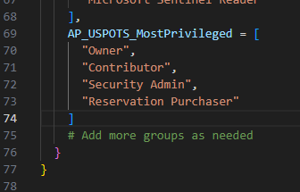

Figure 3 multi role groups in variables.tf

2.3 Grant Graph API Permission via PS
- To grant the Managed Identity the needed API Permissions, a PowerShell script will need to be run from the cloud shell. All scripts stored in the following repository:
  - https://ghred.ustest.rolls-royce.com/RedZoneTest/azure-rz-scripts-pim

- The PowerShell script needed is the “grant-permissions.ps1” in the repository.
- The only modification needed to the script is the name of the managed identity changed on line 3:
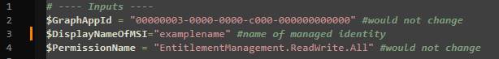
Figure 4 grant-permissions.ps1

2.4 Revoke Graph API Permission via PS
- After the pipeline is completed. The permission can be revoked by the “remove-permissions.ps1” in the repository.
- The only modification needed to the script is the name of the managed identity changed on line 3: 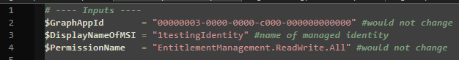
Figure 5 remove-permissions.ps1

2.5 Get Audit Log via PS
- To log the addition and removal of the permission, the script “get-permissionaudit.ps1” will retrieve the audit logs for that day for the specified managed identity, output the values in a csv and write it to a storage account with the date/time in the filename.
  - Ex: Managed_ID_PermissionsAudit-$stamp.csv where $stamp is the Date/Time stamp
- The following input values are needed as shown below:
  - Managed Identity Object ID
  - Resource Group Name
  - Storage Account Name
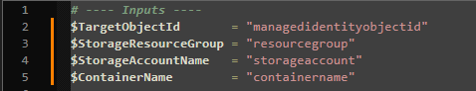
Figure 6 get-permissionaudit.ps1

2.6 Continue Role Settings Change
• The rest of the role settings can now be done according to each tier of group level access:
Most Privileged:
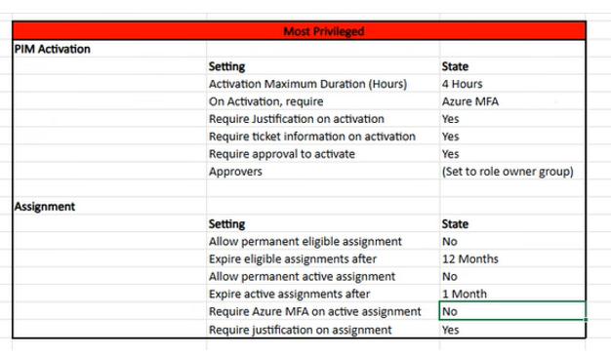
Figure 7 Most privileged Role settings
High Risk
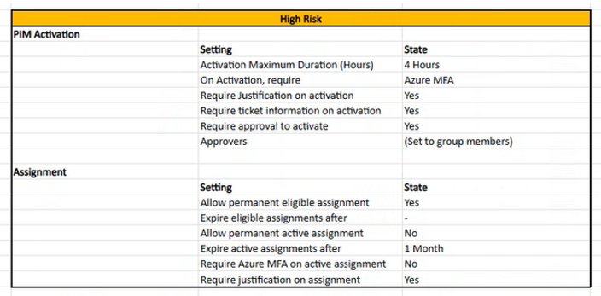
Figure 8 High Risk Role settings

Low Risk
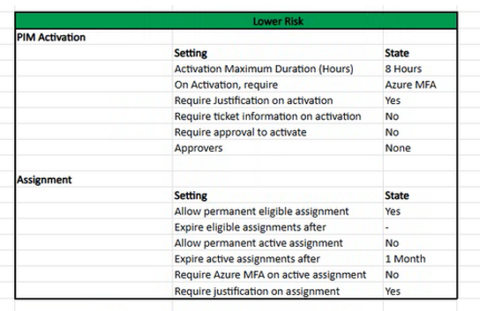
Figure 9 Low Risk Role settings

3. Requesting / Approving Access

3.1 Requesting Access
- Navigate to myaccess.microsoft.com
- Microsoft Access Package Request Access Guide:
  - https://learn.microsoft.com/en-us/entra/id-governance/entitlement-management-request-access

3.2 Approving Access
- An email will be sent to the approvers to approve the request
- If approver does not have a mailbox, navigate to myaccess.microsoft.com to approve
- Microsoft Access Package Approval Guide:
  - https://learn.microsoft.com/en-us/entra/id-governance/entitlement-management-request-approve

